KIA Motors Corporation: Strategic Audit Analysis
[Name]
[Institution affiliation]
[Course]
[Date]

Description of the Company (Structure and products)
Kia Motors Corporation was established on 10th December 1944. Its head office is in Seoul, South Korea. Kia operates in the automotive industry whereby it manufactures and sales motor vehicles. However, Kia divides its operations into the following segments: Recreational vehicles, Passenger cars, and Commercial vehicles (Datamonitor (Firm), (2012). Besides, the company also leases vehicles, provides services concerning vehicle maintenance, and vehicles parts as well.
NAICS Code
336111- Automobile Manufacturing
Kia’s Strategic Vision and Mission Statement
Vision: To achieve trust as a lifetime partner in automobiles and beyond from the customers, and establish a new automobiles’ perspective by using the innovative mobility strategies that are based on providing technologies and services that are eco-friendly and human-centric as well.
Mission: To achieve its vision by having an unlimited responsibility sense while realizing possibilities that have respect to mankind.
Strategies used by the company
Kia Motors strategy is based on five factors, including customer, challenge, collaboration, people, and globality. For Kia to remain competitive in the automotive industry, it promotes a corporate culture that is customer-driven through offering the faultless and high-quality services and automobiles, whereby all the values are centered on its customers (Datamonitor (Firm), (2012). Moreover, Kia refuses to be egoistic and embraces all the potential opportunities meant for a greater challenge. Given such strategies, the company remains confident in accomplishing its vision with ingenious thinking and an enduring passion as well.
Kia’s Business Model
As earlier mentioned, Kia divides its operations into the following segments: Recreational vehicles, Passenger cars, and Commercial vehicles. Also, Kia lease vehicles and provides their maintenance and spare parts as well (Datamonitor (Firm), (2012). Additionally, Kia manufactures hybrid automobiles named under various brand names, including Forte, Cadenza, Optima, Rio, Sorento, and Sedona, etc. Therefore, all these products and services are distributed across the domestic and foreign markets like Europe, Asia, and North America, among others.
Kia’s Ethics & Social Responsibility
Through valuing its people, Kia believes that its organizational future is based on the individual members’ hearts and capabilities, and such people will facilitate its potentiality through developing a corporate culture that respects and values talent (Datamonitor (Firm), (2012). Besides, Kia highly respects cultural diversity and aspires to be the best in the world in what it does as well as striving to be one of the most respected corporate citizens in the globe.
Kia Motors External Environment (Porter 5 Force Model)
There are five primary Porter’s forces that shape the automotive industry and the market structure include the buyers’ bargaining power, suppliers’ bargaining power, competitive rivalry, new entrants’ threat, and the substitutes’ threat (Uzwyshyn, Ray, 2017). The figure below summarizes these five forces:
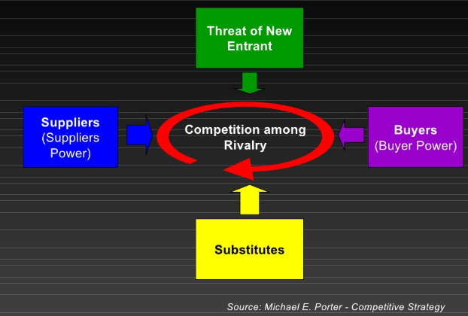
- Automotive Buyers’ Bargaining Power
Currently, buyers’ power to bargain appears to have heavily weighted towards them, with the players in the industry required to remain more vigilant concerning the preferences of the consumers. However, given the recent economic conditions in the world, there is a reduced amount of buyers both in the US and other global markets. Apparently, customers are perhaps keeping their vehicles for long; hence, becoming judicious and more prudent whenever they purchase one (Uzwyshyn, Ray, 2017). On a strategic perspective, however, such an opportunity needs Kia Motors to put more focus on the aspects of price sensitive and fuel efficiency strategies so as to fully shift from the previous centered production and profit models on SUV’s and trucks.
- Automotive Suppliers’ Bargaining Power
According to the Industry Analysis Handbook (2012), the automotive business supply is fragmented. Most of the suppliers depend on one or multiple automakers for buying most of their products (Uzwyshyn, Ray, 2017). Given such dependence, suppliers perhaps are left with little power. As a result, these suppliers become suspicious of the requirements and demand of the vehicle manufacturers. The world steel price is an exception within such bargaining power of suppliers.
- Competitive Rivalry
The graph below represents a longer-term projection for the automotive industry’s competition intensity and it remains quite telling:
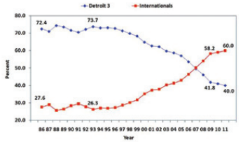
As it is seen, the graph presents a consummate description of the US motor vehicles’ market share as a sales percentage of the leading companies against foreign competitors. Considering a ten-year point of view, the trend is perhaps shifted from the leading automotive companies that enjoy a domestic market share of 60% to the contrary, with foreign automotive firms holding a market share of 60%. However, if such a trend persists for the next ten years, there will be a shift to 73% and 25% for the international and domestic market shares respectively. Nevertheless, Kia’s future strategy remains clear- it is upon the firm to consider what the other market participants are using and then copy and advance upon them (Uzwyshyn, Ray, 2017). Notwithstanding, the trend implies that there is a lack of enough vigilance by the domestic manufacturers concerning such a threat. Therefore, Kia needs to adopt some strategies, including maximization of the utilization capacity through plant efficiencies that minimize the operating costs.
- New Entrants’ Threat
Given that the entry barriers to the automotive industry in the US is increasing, the heightening global economic nature and the relatively current foreign competitors’ emergence with technology, capital, marketing, and management skills expose a potential threat to the domestic market. Therefore, from a strategic perspective, Kia Motors needs to further discover the global opportunities and focus on its competitors’ market penetration and incursion as well. As a new entrant in the market, Kia can currently leverage the existing potential and cash flow more easily in shaking up the market share ranks further.
- Substitutes’ Threat
The current economic world is perhaps dominated by the automobile manufacturing increase. Such a trend is anticipated to change in future. Among the primary factors is the change in acquiring and pricing gasoline and oil, impacting the willingness of consumers in buying a new or old automobile. Such increased costs will perhaps result in a smaller segment of the consumer market if such high fuel efficiency levels are not combined with the achieved lower ownership costs (Uzwyshyn, Ray, 2017). Moreover, the more attenuate structural threats involve the higher shift from an industrial base, with urban and commuter culture to a knowledge economy. Such a shift is likely to lower the need for multiple automobiles in every household.
Key Factors to become a successful competitor
The automotive industry is partly protected because of the high barriers’ entry for new products development, including costs of vehicle development, production equipment, marketing, and advertisement infrastructure (Uzwyshyn, Ray, 2017). Therefore, Kia Motors needs to manufacture hybrid vehicles that use alternative sources of fuel. Also, the company needs to consider and apply robust opportunities for wireless networks and digitize the current possibilities for embedding further technology within the system of its vehicles. One of the added advantage to the firm’s business model is that the automotive industry is an oligopoly market dominated by a small number of manufacturers. Such a market remains to be mutually interdependent and the firms face the same challenges.

References
Datamonitor (Firm), (2012). Kia Motors Corporation- Company Profile.
Uzwyshyn, Ray. (2017). The US auto industry in 2017: Five forces to consider. 192.

